December 18, 2020
Ref: IIH/MD/2020/12/012
His Excellency,
The Executive Governor of Kwara State,
Government House,
Ahmadu Bello Way,
GRA, Ilorin, Kwara State.
Your Excellency Sir,
RE: REQUEST TO SETUP ADVISORY GROUP FOR KWARA STATE
In response to your question commented on our initial letter with the above subject, and my initial suggestion for honorarium deemed too high, my new suggestion for honorarium for each member of this group is N150,000 (One hundred and fifty thousand naira only) per quarter.
Yours truly,
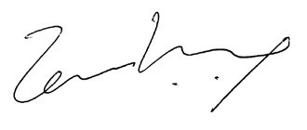

Temi Kolawole
MD Ilorin Innovation Hub

